TASK 2
- List 3 real-world devices in your home or college that use SMPS (Switched Mode Power Supply) and 2 devices that use UPS (Uninterruptible Power Supply), explaining in one line why each device needs that type of power supply.

ANS: Devices Using SMPS (Switched Mode Power Supply)
- 1. Desktop Computer / PC: Needs an SMPS to efficiently convert household AC power into multiple stable, regulated DC voltage rails (+12V, +5V, +3.3V) required by internal components.
- 2. LED Television / Monitor: Uses an SMPS to step down and convert high-voltage AC into low-voltage DC power efficiently while keeping the chassis slim and lightweight.
- 3. Laptop Charger / Smartphone Adapter: Employs a compact miniature SMPS to convert AC wall power into safe, regulated low-voltage DC power for battery charging.

Devices Using UPS (Uninterruptible Power Supply)
- 1. Desktop Computer / Workstation: Connected to a UPS to provide immediate backup battery power during a blackout, preventing data loss and allowing safe system shutdown.
- 2. Wi-Fi Router / Network Switch: Uses a UPS to maintain continuous internet connectivity and prevent network drops during sudden power failures or voltage fluctuations.

- Draw and label a diagram showing the main internal components of a typical SMPS unit found in a desktop PC, including AC input, rectifier, transformer, and DC output sections.<br><br><em><strong>Hint:</strong> You can hand-draw and upload a photo, or use any free diagram tool like draw.io.</em
ANS: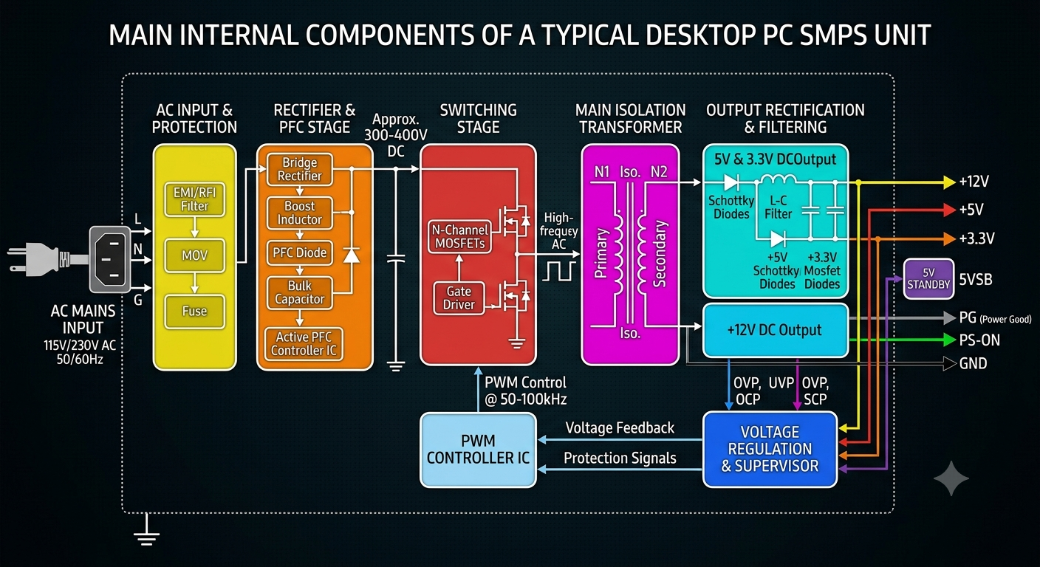

- . .Take photos or find clear images online of the following power connectors: ATX 24-pin motherboard connector, SATA power connector, Molex connector, and PCIe 6/8-pin connector. For each, write its name, the devices it powers, and one safety tip for connecting/disconnecting it.
ANS: . 1. ATX 24-Pin Motherboard Connector
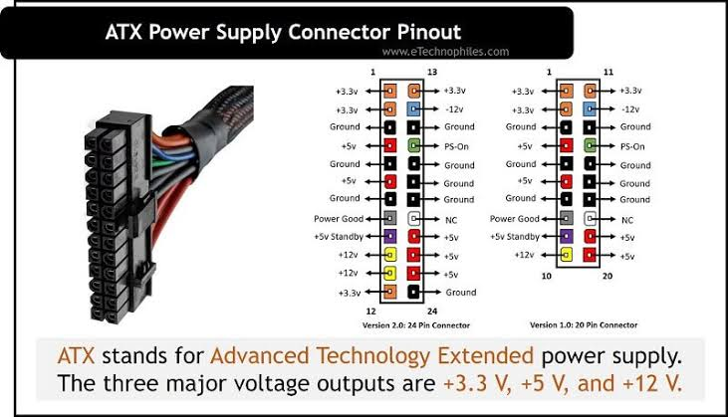
• Name: ATX 24-Pin Motherboard Connector
• Devices Powered: The main motherboard, onboard controllers, PCIe slots, and integrated components.
• Safety Tip: Always ensure the locking latch is fully engaged and click-secured into place before powering on the system. When disconnecting, press down firmly on the plastic release tab to avoid ripping the motherboard header or bending delicate pins.
2. SATA Power Connector
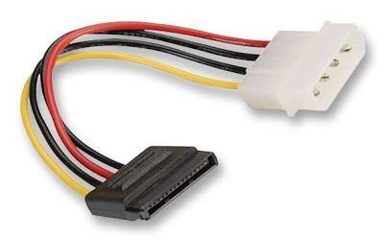
• Name: SATA (Serial ATA) Power Connector
• Devices Powered: 2.5-inch/3.5-inch SATA Hard Disk Drives (HDDs), Solid State Drives (SSDs), and optical disc drives.
• Safety Tip: SATA power plugs are wide and thin; push them straight in horizontally without twisting or rocking sideways to prevent cracking the fragile L-shaped plastic housing on the drive.
- Molex Connector
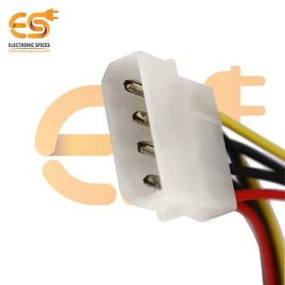
• Name: Molex 4-Pin Peripheral Connector
• Devices Powered: Legacy peripherals, older case fans, pump units, fan controllers, and certain LED lighting hubs.
• Safety Tip: Molex connectors often fit together very tightly. Never pull hard by the individual wires to disconnect them; instead, firmly grasp both the male and female plastic housings and gently wiggle them apart.
- PCIe 6/8-Pin Connector
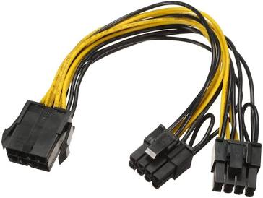
• Name: PCIe 6/8-Pin Power Connector
• Devices Powered: Dedicated Graphics Processing Units (GPUs / graphics cards).
• Safety Tip: Double-check that you are using a dedicated PCIe power cable from your power supply and not a CPU 8-pin (EPS) cable, as their pinouts are completely different and plugging in the wrong one can permanently damage your GPU.

4. Imagine you are setting up a new gaming PC. List the steps you would follow to connect the SMPS to the motherboard, graphics card, and storage devices, mentioning which specific cables and connectors are used for each.

ANS: Step 1: Prepare and Plan Your Cabling
- Action: Before installing components into the case (or right after mounting the SMPS), plan your cable routing using the rubber grommets behind the motherboard tray for a clean build.
- Cables Used: Modular or semi-modular SMPS cables (bundled with the power supply).
- Safety Tip: Always ensure the power supply switch is toggled to the Off position (0) and the power cable is unplugged from the wall outlet before touching any internal components.

Step 2: Connect the Motherboard (ATX 24-Pin and CPU 8-Pin)
- Action: Plug the thick ATX 24-pin cable from the SMPS into the corresponding 24-pin power slot on the right side of the motherboard until the plastic latch clicks. Then, connect the EPS/CPU 8-pin (or 4+4 pin) cable from the SMPS into the CPU power header located near the top-left of the motherboard.
- Cables/Connectors Used:
  - ATX 24-Pin Connector for main board power.
  - EPS 8-Pin / 4+4 Pin Connector for the CPU.
- Safety Tip: Double-check that you are plugging the CPU 8-pin cable into the CPU header and not a PCIe 8-pin cable, as their pin configurations are inverted and can cause severe damage.

Step 3: Connect the Graphics Card (GPU)
- Action: Insert your graphics card firmly into the top PCIe x16 slot. Take the appropriate power cables from your SMPS and plug them securely into the power receptacles on the side/rear of the GPU.
- Cables/Connectors Used: PCIe 6/8-Pin Connectors (often labeled "PCIe" or "VGA" on modular power supplies; some high-end cards may use the newer 12VHPWR/12V-2x6 cable).
- Safety Tip: If your GPU requires an 8-pin connector and your cable is a 6+2 pin split design, make sure the "+2" pin portion is securely held flush against the "6" pin block so they enter the GPU socket smoothly together as a single unit.

Step 4: Connect Storage Devices (SSDs and HDDs)
- Action: Mount your 2.5-inch SSDs, 3.5-inch HDDs, or plug your M.2 NVMe drives (note: M.2 drives draw power directly from the motherboard slot and do not need a cable). For standard SATA storage drives, run a flat cable from the SMPS to the drive's power port.
- Cables/Connectors Used: SATA Power Connector (a flat, wide 15-pin plug).
- Safety Tip: SATA power connectors are thin and wide; push them in straight without bending or twisting them sideways to avoid cracking the fragile plastic L-shaped connector casing on the drive.

Step 5: Final Inspection
- Action: Check all connections to ensure every latch is clicked into place and no wires are pinched or resting against sharp edges or high-speed fan blades.
- Follow-up Question: Are you building with a fully modular power supply, or are you working with a non-modular unit where excess cables need to be tucked away?

